
National Textile University
Department of Computer Science
Subject:
MAD

Submitted to:
Sir Rehan Sarwar

Submitted by:
Asbah Asif

Reg number:
23-NTU-CS-1141

Lab:
05

Semester:
6th

Task: 1
Code:
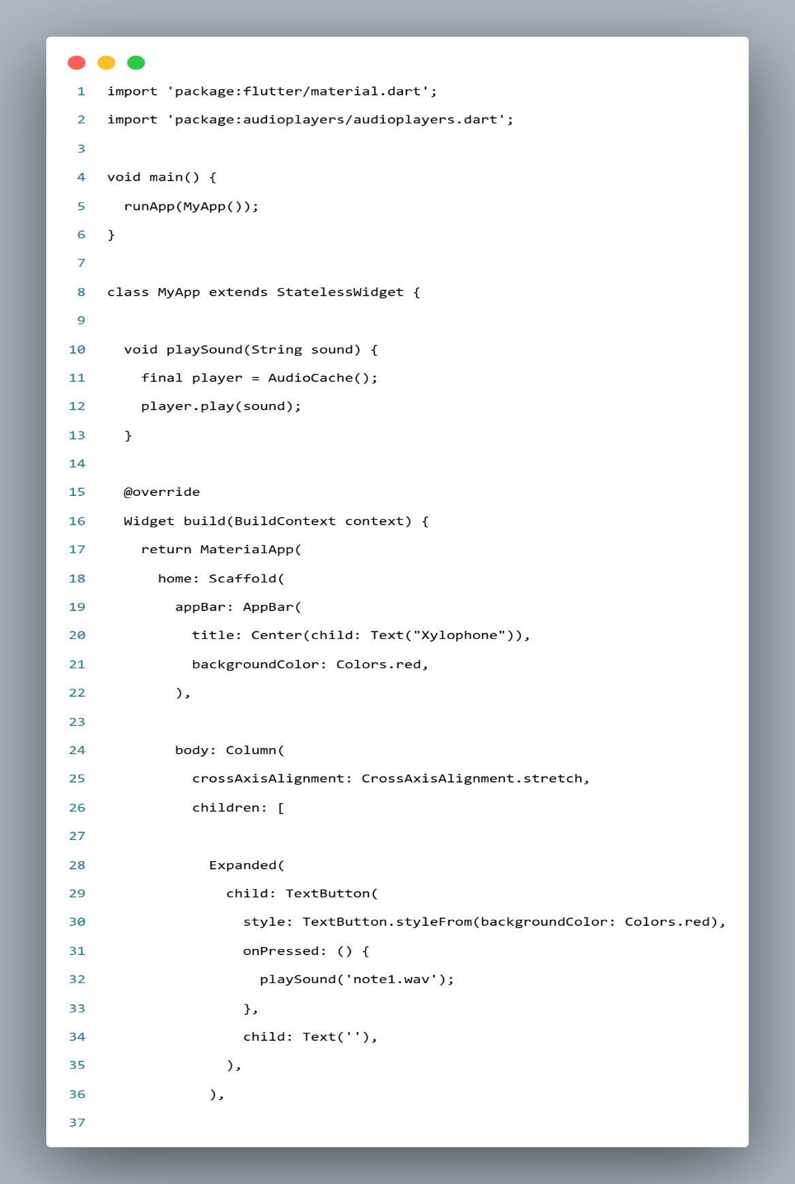
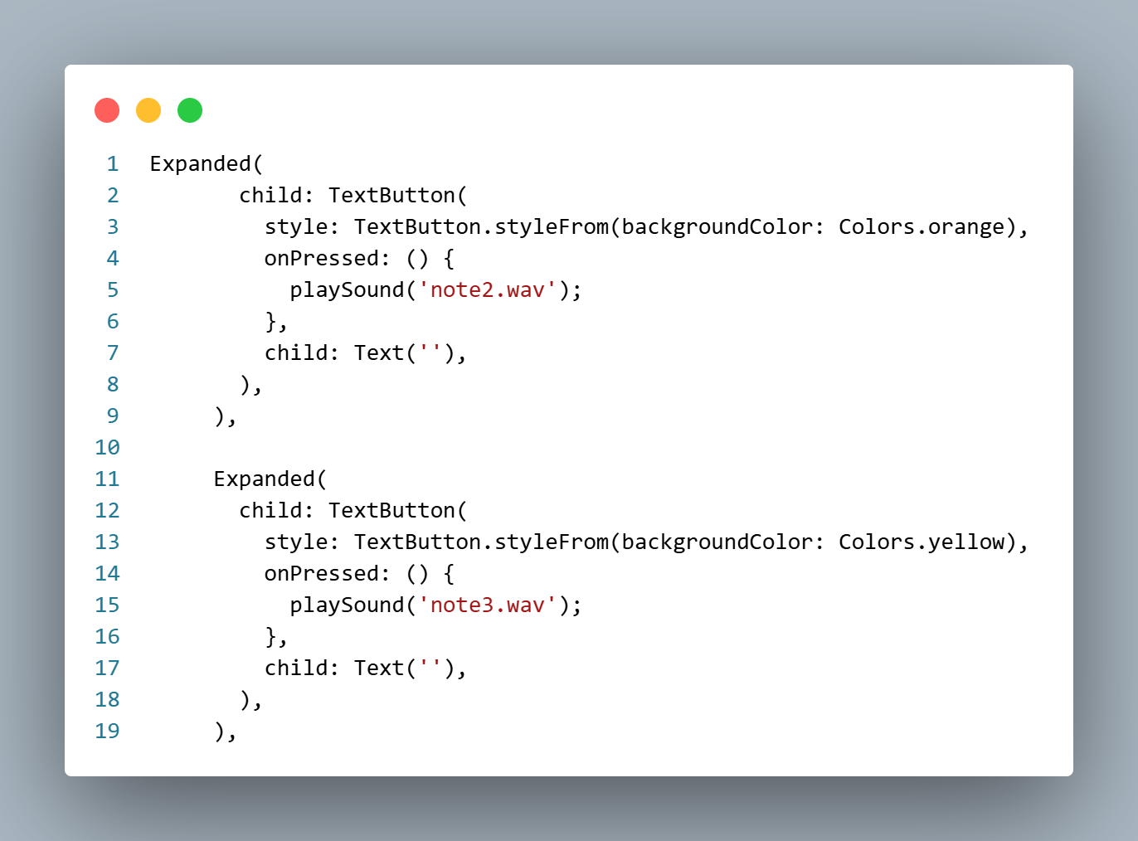
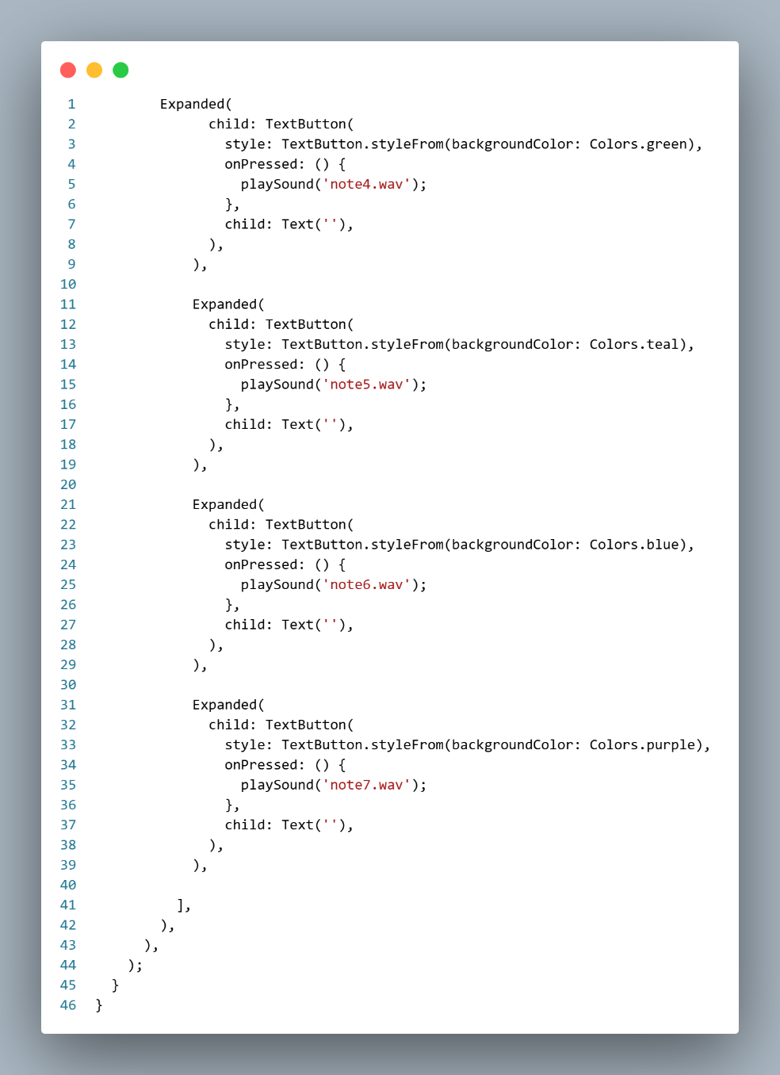
Output:
